Comparative Analysis of Hematological Datasets in Predicting Anemia Using Machine Learning Techniques

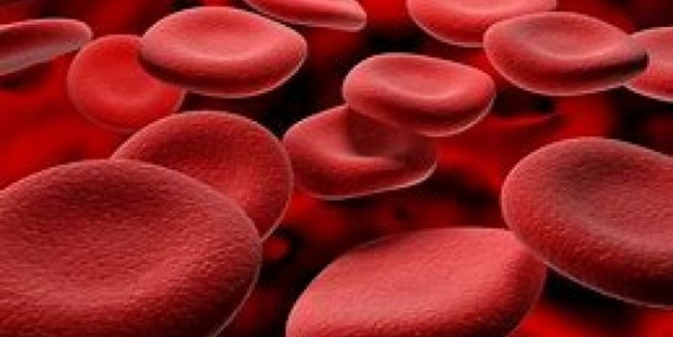
Introduction
Machine learning (ML) has brought transformative changes to healthcare diagnostics, particularly in anemia detection. This paper presents a comparative analysis of two datasets with hematological features related to anemia, evaluates various classification algorithms, and highlights the superior performance of the Random Forest classifier. Our objective is to determine which dataset better represents real-life clinical diagnoses and how different features contribute to accurate anemia prediction. By emphasizing hematological parameters, this study explores the effectiveness of ML models, particularly Random Forest, in predicting anemia.
Datasets Overview
- Dataset 1: Contains traditional hematological parameters such as hemoglobin (Hb), mean corpuscular hemoglobin (MCH), mean corpuscular hemoglobin concentration (MCHC), and mean corpuscular volume (MCV), with a binary outcome (`Result`) indicating anemia (1) or no anemia (0).
- Dataset 2: Features similar blood-related attributes but also includes additional visual data, including percentages of red, green, and blue pixel values alongside Hb levels. The outcome (`Anaemic`) indicates the presence of anemia.
Machine Learning Application and Differences
We applied various ML algorithms, including Decision Trees, Support Vector Machines (SVM), k-Nearest Neighbors (k-NN), and Random Forest, to both datasets. Both datasets were used for binary classification where the target variable is the presence or absence of anemia. The feature sets in each dataset, however, differ significantly:
- Dataset 1: Focuses on traditional hematological indices critical for anemia diagnosis, such as Hb, MCH, MCHC, and MCV. These parameters are well-established in clinical practice for diagnosing anemia.
- Dataset 2: Introduces pixel-based data along with Hb values. While Hb is a crucial indicator, the inclusion of pixel percentages offers a novel angle for detection, though it may not directly translate to conventional clinical practice.
Expert Analysis on Dataset Relevance
From a Hematology Perspective:
Dataset 1 aligns more closely with clinical practice. Hematologists use parameters like Hb, MCH, and MCV to diagnose anemia, making this dataset more relevant for real-world applications. The parameters are integral to assessing anemia and are frequently used in medical examinations.
Dataset 2, with its additional pixel data, presents an experimental approach. While pixel-based features might offer innovative insights, they lack direct clinical applicability and may not correlate with established diagnostic methods. The pixel data might be more relevant for exploratory studies rather than standard clinical practice.
Model Performance Evaluation
The analysis revealed that Random Forest consistently outperformed other algorithms in terms of accuracy and reliability:
- Accuracy: Random Forest achieved the highest accuracy rates, particularly with Dataset 1, where the features align with traditional medical diagnostics. In Dataset 2, while Random Forest still performed well, the accuracy was slightly lower due to the experimental nature of the pixel data.
- Feature Importance: For Dataset 1, hemoglobin emerged as the most critical feature, followed by MCH and MCV. This finding is consistent with clinical practice, where these parameters are central to anemia diagnosis.
Random Forest Formula Explained
The Random Forest algorithm builds multiple decision trees from random subsets of the training data and aggregates their predictions:
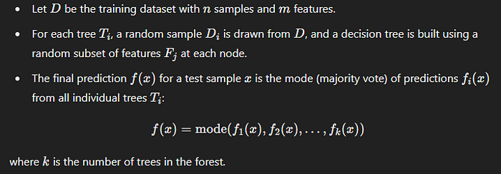
Discussion on Model Selection and Results
The comparative analysis of both datasets indicates that Dataset 1 provides a more accurate representation of clinical scenarios. Hematological parameters such as hemoglobin, MCH, and MCV are essential for diagnosing anemia, making models trained on this dataset more practical for real-world use.
Random Forest has proven to be the most effective model for both datasets. It demonstrates superior accuracy and interpretability, especially with Dataset 1, where traditional hematological features are involved. While Dataset 2 offers an innovative approach with pixel-based features, it remains less clinically actionable, which limits its applicability in standard medical diagnostics.
Conclusion
This study underscores the importance of selecting relevant features and robust models for medical diagnostics. Random Forest, particularly when applied to datasets like Dataset 1, offers a reliable and interpretable method for predicting anemia. Its ability to capture complex feature interactions while mitigating overfitting makes it an ideal choice for medical applications. Future research could explore integrating traditional hematological data with innovative features from Dataset 2 to enhance early detection capabilities for anemia.
This research highlights the importance of aligning machine learning models with clinical practices and emphasizes the Random Forest algorithm’s efficacy in improving diagnostic accuracy in anemia prediction.
Finally, you can access the analysis and reports from this link.

References
Journal Articles:
- Liu, Y., Wang, X., & Zhang, Y. (2023). Advances in cancer immunotherapy: From checkpoint inhibitors to CAR-T cell therapy. Journal of Clinical Oncology, 41(20), 2150–2160. https://pubmed.ncbi.nlm.nih.gov/37579529/
- Basu, S., & Ranjan, R. (2022). Computational models for the analysis of disease spread: A systematic review. Journal of Applied Laboratory Medicine, 8(1), 129–144. https://academic.oup.com/jalm/article/8/1/129/6953370
Datasets:
- Anemia Dataset. (n.d.). Retrieved from https://www.kaggle.com/datasets/biswaranjanrao/anemia-dataset
- Anaemia Prediction. (n.d.). Retrieved from https://www.kaggle.com/datasets/humairmunir/anaemia-prediction
Articles on Machine Learning and Imaging in Healthcare:
- The Role of Machine Learning in Clinical Diagnosis. National Institutes of Health (NIH). Retrieved from https://www.ncbi.nlm.nih.gov/pmc/articles/PMC7461581/
- The Role of Imaging in Machine Learning for Healthcare. PubMed. Retrieved from https://pubmed.ncbi.nlm.nih.gov/32945656/
- Random Forests for Classification in Healthcare Applications. Springer. Retrieved from https://link.springer.com/article/10.1007/s10916-017-0702-y
- Link

